RAM KRISHNA COLLEGE, MADHUBANI
B.Ed. STUDENTS DETAILS – 2018-20
ROLL NO. | NAME OF THE STUDENTS | FATHERS NAME | PICTURE
1 | NAVIN KUMAR | JAGANNATH PRASAD | 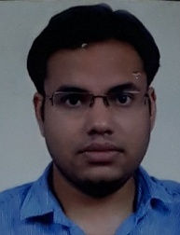
2 | SURESH KAMAT | KUSHESHWAR KAMAT | 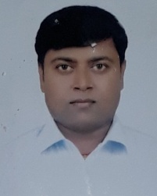
3 | RAHUL KUMAR JHA | DHANPATI JHA | 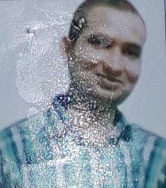
4 | SANTOSH KUMAR SAHU | RAJENDRA PRASAD SAHU | 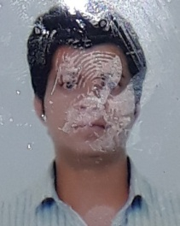
5 | VIRENDRA KUMAR SAH | SATYA NARAYAN SAH | 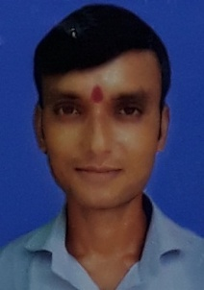
6 | GANESH KUMAR BHAGAT | OM PRAKASH BHAGAT | 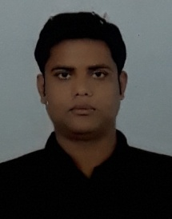
7 | GANESH KUMAR SAH | RAM PRIKSHAN SAHU | 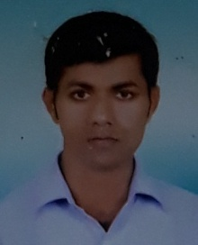
8 | VIVEK KUMAR | KAILASH PRASAD SAHU | 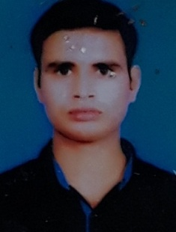
9 | ABHISHEK KUMAR | KHUSHI LAL SAH | 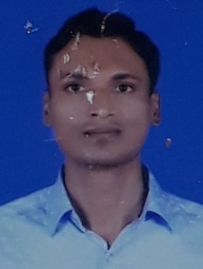
10 | GUDDU KUMAR | NARESH NARAYAN PRASAD | 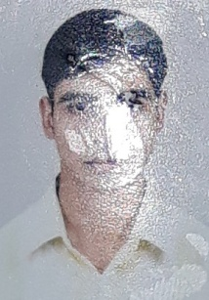
11 | BIRANCHI NARAYAN SHARDA | RAS LAL | 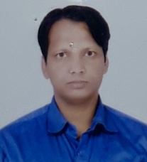
12 | ANIL KUMAR PASWAN | RAM AUTAR PASWAN | 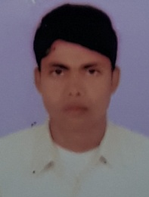
13 | SUBHASH YADAV | UMESH YADAV | 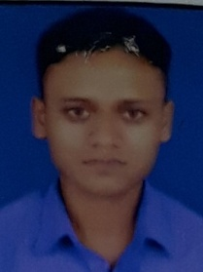
14 | RAHUL KUMAR SAFI | PRADIP SAFI | 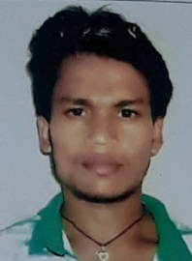
15 | SOMDEV KUMAR JHA | SAROJA NAND JHA | 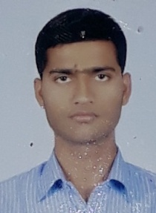
16 | SAROJ YADAV | RAM UDGAR YADAV | 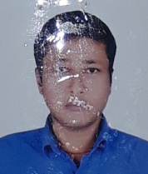
17 | MANOJ KUMAR SHARMA | RAM KEWAL SHARMA | 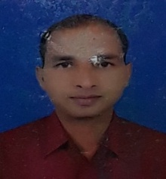
18 | DINBANDHU MISHRA | CHANDRA KANT MISHRA | 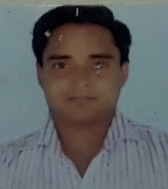
19 | PRAVEEN KUMAR | RAGHUNATH RAM | 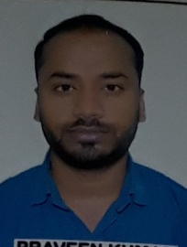
20 | KRISHNA KUMAR | SURESH MAHTO | 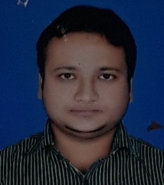
21 | SAROJ KUMAR RAY | BAIDYANATH RAY | 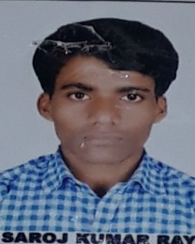
22 | AMAN RAJ | CHANDRA KUMAR LAL DAS | 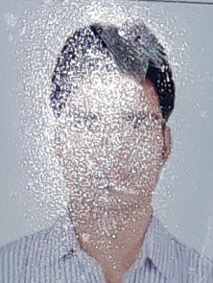
23 | KAILASH KUMAR ROY | JEET NARAYAN ROY | 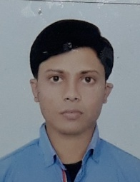
24 | MANOJ PASWAN | GULSHAN PASWAN | 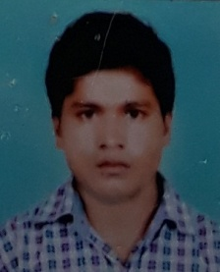
25 | SAROJ RAM | JAGDEESH RAM | 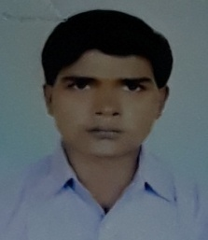
26 | SAURABH KUMAR | RAM SEVAK MANDAL | 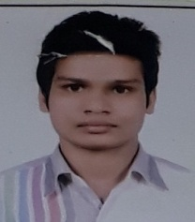
27 | ABHISHEK BHARGAV | RAM KUMAR SAHU | 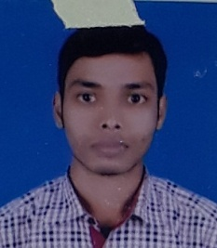
28 | DURGESH BHANDARI | RAMBRIKSH BHANDARI | 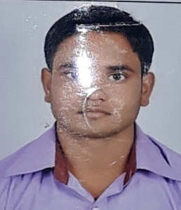
29 | SHOBHA KUMARI | BAIDYANATH PRASAD SAHU | 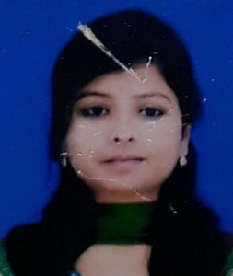
30 | MANISH KUMAR | OM PRAKASH SAH | 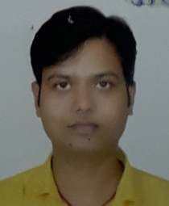
31 | SARITA KUMARI | TEJ NARAYAN PRASAD | 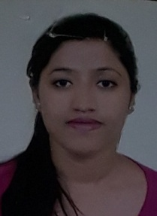
32 | SHIV KUMAR CHAUPAL | RAM ASHISH CHAUPAL | 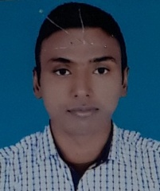
33 | LALIT KUMAR SAHU | BHUWANESHWAR SAHU | 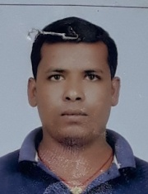
34 | MD. IMTIYAZ ALI | IMAM ALI | 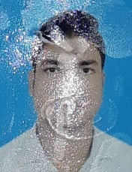
35 | NAVEEN KUMAR | SHIV KUMAR SAH | 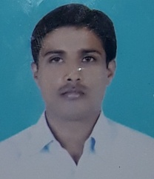
36 | KRISHNA KUMAR MAHTO | SHIVSHANKAR MAHTO | 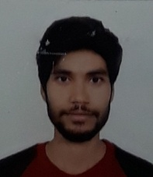
37 | NITISH KUMAR CHAUDHARY | RAJ LAL CHAUDHARY | 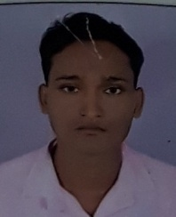
38 | YOGESH KUMAR | SHOBHA MANDAL | 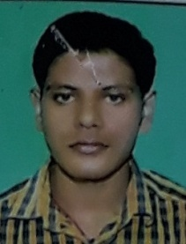
39 | SUNIL KUMAR YADAV | SHIV NANDAN YADAV | 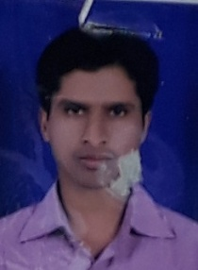
40 | DIWESH KUMAR DAS | RATTAN DAS | 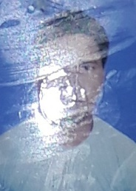
41 | NARESH KUMAR | SITARAM MANDAL | 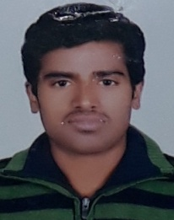
42 | DHARMENDRA KUMAR | JAGANNATH PRASAD | 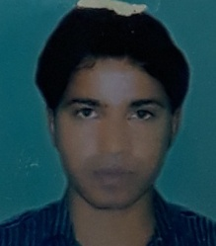
43 | NITU KUMARI | SHYAM CHANDRA BHAGAT | 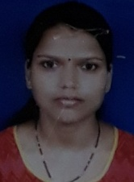
44 | AMIT KUMAR JHA | ANAND CHANDRA JHA | 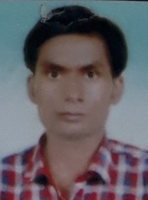
45 | SONU KUMAR CHOUDHARY | MADAN KUMAR CHOUDHARY | 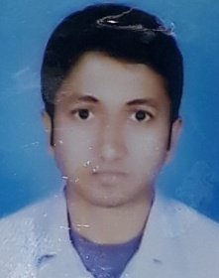
46 | RAMESH KUMAR YADAV | RAJ KUMAR YADAV | 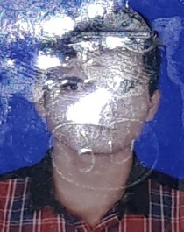
47 | MD. FARUQUE | MD. BUJHAN | 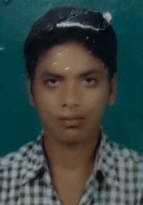
48 | KRISHNA KUMAR | GANGA PRASAD RAY | 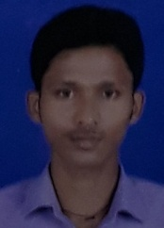
49 | SUMAN KUMAR SAFI | RAJENDRA SAFI | 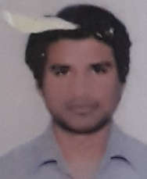
50 | KAILASH KUMAR | KHUSHI LAL MANDAL | 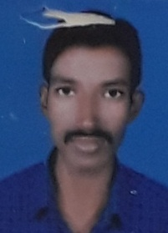
51 | HARIDEO RAM | KUJEELAL RAM | 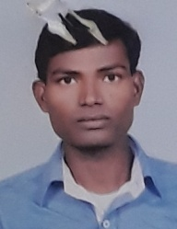
52 | PRAKASH KUMAR SINGH | RAM BIHARI SINGH | 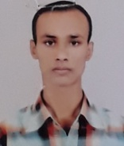
53 | BINITA KUMARI | RAJESHWAR SINGH | 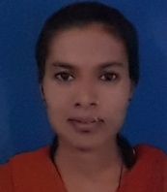
54 | HARIOM ROUT | SHIV LAL ROUT | 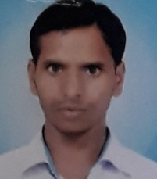
55 | JYOTISH KUMAR | INDRA DEO CHAURWAR | 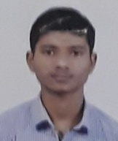
56 | RAMASHISH KUMAR RAM | RAM SUNDAR RAM | 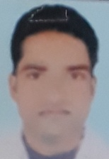
57 | LALAN KUMAR MANDAL | MUSH HARU MANDAL | 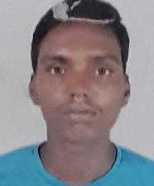
58 | LALIT KUMAR MISHRA | PARMANAND MISHRA | 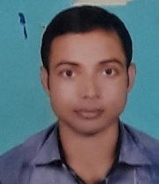
59 | PUNIT KUMAR JHA | SHAILENDRA KUMAR JHA | 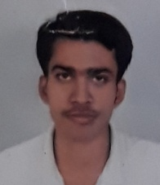
60 | ASHOK KUMAR CHOUDHARY | RAJESHWAR MAHTO | 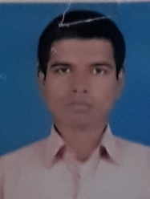
61 | NILMANI THAKUR | UMESH THAKUR | 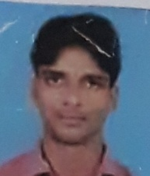
62 | SHUBHAM KUMAR CHOUDHARY | MAHENDRA CHOUDHARY | 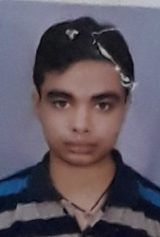
63 | JEEBNATH KUMAR YADAV | GANGAI YADAV | 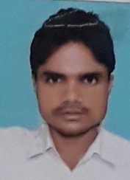
64 | ANKIT KUMAR | GULAB SAH | 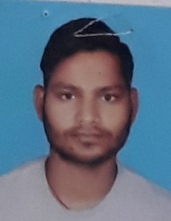
65 | JAGAT NARAYAN MANDAL | GOSAIN MANDAL | 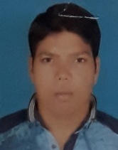
66 | RAVI SHANKAR KUMAR | BHOLA MAHTO | 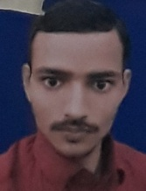
67 | UMESH MAHTO | BHAGLU MAHTO | 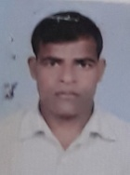
68 | RABINDRA KUMAR RAVI | SHAUKHI LAL YADAV | 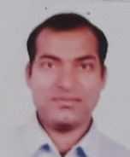
69 | ASHOK KUMAR PANDIT | JIBACHH PANDIT | 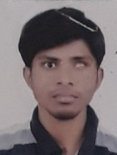
70 | RAM KUMAR RAM | SHYAM KISHOR RAM | 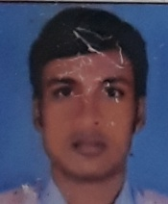
71 | ANAMIKA KUMARI | KAUSHAL KISHOR | 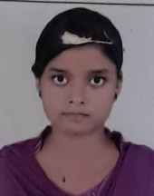
72 | JEEBU PASWAN | CHAITU PASWAN | 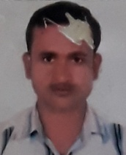
73 | BABAR PASWAN | SUNIL KUMAR PASWAN | 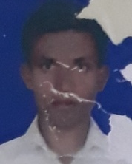
74 | RAGHU CHANDRA | HEM CHANDRA MISHRA | 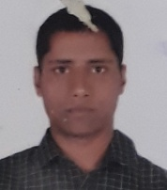
75 | ASHISH ANAND | ARUN PANDEY | 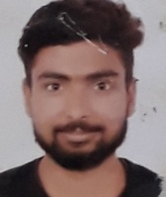
76 | RAMESH KUMAR | PALTU SAH | 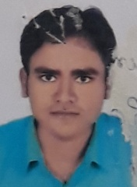
77 | NAVAL KUMAR CHAUDHARY | RAMESHWAR CHAUDHARY | 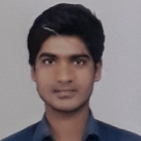
78 | SHYAMA NAND | UMAKANT YADAV | 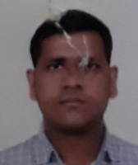
79 | KAUSHAL KUMAR MALAKAR | KAILASH BHAGAT | 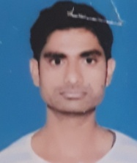
80 | PANKAJ KUMAR | RAJ KUMAR SINGH | 